

### Project Report on

**Enhancing agricultural monitoring using AI Enabled drone**

Submitted to

### LOVELY PROFESSIONAL UNIVERSITY

in partial fulfillment of the requirements for the award of degree of

### Bachelor of computer application

### Project Group – DC023

**Submitted By: Supervised by:**

**Sudhanshu Ranjan (12112221) Asst. Prof. Jaswinder singh Husain Ahmed Qadri (12105882)** (School of Computer Application) **Shubham Raj (12115151)**

**LOVELY FACULTY OF COMPUTER & APPLICATIONS LOVELY PROFESSIONAL UNIVERSITY, PUNJAB**

**[Jan 2024 to April 2024]**

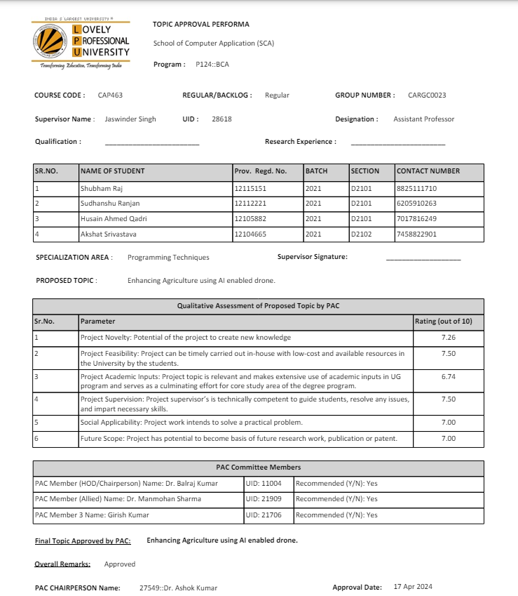

# CERTIFICATE

This is to certify that Sudhanshu Ranjan, Hussain Ahmed Qadri, Shubham Raj, has completed doing Capstone Project “Enhancing agricultural monitoring using AI Enabled drone “ under my guidance and supervision. To the best of my knowledge the present or the result of his original study. No part of the report has ever been submitted for any other degree or diploma. The report is fit for the submission and the partial fulfillment of the conditions for the award of BCA.

[Date] Jaswinder Singh

# Acknowledgment

We wish to record my heartfelt gratitude and sincere thanks to Mr. Jaswinder Singh, Asst. Professor, School of Computer Science and Application, Lovely Professional University Phagwara (Punjab), for her kind support and inspiration given to us till the end of our project.

We thank Mr. Ashok Kumar, Head of School, School of Computer Science and Application, Lovely Professional University Phagwara (Punjab) for their constant support and encouragement given throughout the development of the project.

Last but not least our sincere thanks to our parents, family members and friends for their continuous support , inspiration and encouragement, without which this project would not have been a success.

Sudhanshu Ranjan

Husain Ahmed Qadri

Shubham Raj

# Table of Contents

|  |  |  |
| --- | --- | --- |
| **Chapters** | **Particulars** | **Page No.** |
| Chapter 1 | Introduction | 6 - 10 |
| Chapter 2 | Literature Review | 11 - 13 |
| Chapter 3 | Methodology | 14 - 17 |
| Chapter 4 | System Analysis | 18 - 20 |
| Chapter 5 | System Design | 21 - 22 |
| Chapter 6 | Implementation & Testing | 23 |
| Chapter 7 | Results | 24 |
| Chapter 8 | Conclusion | 25 |
| Chapter 9 | References | 26 |

**Chapter 1: Introduction**

Agriculture, the backbone of human civilization, is constantly evolving to meet the demands of a growing population while keeping environmental considerations in mind. In this context, technical innovations play a key role in transforming traditional agricultural practices into efficient, sustainable and knowledge-based systems. The advent of drones equipped with advanced sensors is a significant milestone in agricultural monitoring as it provides real-time information on soil quality, plant health and environmental conditions.

The invention, titled "Agriculture Revolution Using Open AI Drone to Improve Monitoring and Sustainability" is an innovative solution developed by a team of innovative thinkers led by Jaswinder Singh, Sudhanshu Ranjan, Husain Ahmed Qadri and Shubham Raj. This invention solves the pressing challenges of modern agriculture by integrating cutting-edge technology, including artificial intelligence (AI), the Internet of Things and drone technology.

At the heart of the invention is a versatile agricultural monitoring solution - a convertible/convertible drone that seamlessly moves between ground and air operations to perform comprehensive field analysis. This multifunctional device combines the functions of both a ground vehicle and a drone, offering unprecedented efficiency and flexibility in agricultural monitoring.

Equipped with advanced gas sensors, the drone-car hybrid allows real-time detection and verification of specific gases that indicate various agricultural conditions, such as soil nutrient levels, pest infestation or environmental pollution. The sedan structure allows for easy maneuvering in various terrains, while the aerial features enable surveillance and data collection over large agricultural areas.

The invention addresses key challenges in modern agriculture, including the need for close monitoring, early intervention and sustainable practices. Using artificial intelligence algorithms and data analysis, the system provides farmers with practical knowledge to optimize crop management strategies, reduce risks and promote environmental protection. In addition, the integration of cloud-based services facilitates data storage, analysis and remote access, allowing farmers to make real-time decisions.

In addition, the invention is in line with global efforts to curb sustainability and climate change in the agricultural sector. By monitoring greenhouse gas emissions, optimizing resource use and promoting precision farming techniques, it helps reduce environmental impact and promote long-term sustainability of agriculture.

Together, the invention represents a paradigm shift in agricultural monitoring and management and offers a comprehensive solution to improve productivity, efficiency and sustainability in modern agricultural practices. Through innovation and collaboration, it paves the way for a more sustainable and environmentally friendly agricultural sector ready to face the challenges of the 21st century.

## Problem Definition and Objectives

## Problem definition:

## The agricultural sector faces many challenges related to monitoring environmental factors and implementing efficient agricultural practices. Traditional methods of monitoring soil quality, moisture levels, and pest distribution often lack real-time data and accurate measurements, leading to suboptimal decision-making and resource use. In addition, environmental pollution and greenhouse gas emissions from agriculture contribute to climate change and environmental pollution, which pose significant challenges to sustainable agricultural practices.

## Objectives:

## Real-time monitoring: Develop a solution to monitor environmental factors such as soil quality, moisture and harmful gases in agricultural fields in real time.

## Early Intervention: Facilitates early intervention by detecting VOCs released by diseased plants or pests, preventing crop damage and minimizing yield loss.

## Optimize fertilizer use: Use gas sensors to optimize fertilizer by accurately measuring soil nutrient levels, reducing over-fertilization and improving yield.

## Environmental monitoring: Enable drones equipped with gas sensors to monitor air quality, identify sources of pollution and assess the environmental impact of agriculture, promoting sustainable agricultural practices.

## Climate Change Mitigation: Contribute to Climate Change mitigation by monitoring greenhouse gas emissions from agriculture and implementing strategies to reduce carbon emissions.

## Improve efficiency and sustainability: Develop a solution that improves the efficiency and sustainability of agricultural practices by providing farmers with actionable insights and data-driven recommendations.

## Detailed Explanation:

## Real-time Monitoring: The goal is to develop a solution that allows farmers to monitor environmental factors in real time, enabling timely intervention and decision-making. Drones equipped with gas sensors offer the ability to continuously collect data, providing farmers with up-to-date information on soil quality, moisture levels and gas concentrations.

## Early Intervention: By detecting VOCs caused by diseased plants or pests, drones equipped with gas sensors facilitate early intervention to prevent crop damage. Farmers receive alerts and notifications when anomalies are detected, allowing them to take immediate action to reduce risk and maintain crop health.

## Optimize fertilizer application: Gas sensors integrated in drones can accurately measure soil nutrient content, allowing farmers to optimize fertilizer application. By avoiding excessive fertilization and ensuring optimal nutrient levels, farmers can improve yields while minimizing input costs and environmental impact.

## Environmental monitoring: Drones equipped with gas sensors play a vital role in monitoring air quality, identifying sources of pollution and assessing the environmental impact of agriculture. By gathering information about greenhouse gas emissions and pollution levels, farmers can take steps to minimize environmental impacts and promote sustainable farming practices.

## Climate Change Mitigation: By monitoring and implementing strategies to reduce carbon dioxide emissions, drones equipped with gas sensors contribute to climate change mitigation efforts in the agricultural sector. By reducing greenhouse gases and adopting sustainable practices, farmers can reduce their environmental footprint and contribute to global efforts to mitigate climate change.

## Improve efficiency and sustainability: In general, the goal is to develop a solution that improves the efficiency and sustainability of agricultural practices. By providing practical knowledge and knowledge-based recommendations to farmers, drones equipped with gas sensors enable informed decisions, optimize resource management and promote sustainable agricultural practices for long-term viability and environmental protection.

Overall, the goal is to harness the capabilities of gas-sensing drones to revolutionize agriculture by enabling precise, efficient and sustainable farming practices while reducing environmental impact and contributing to global climate change mitigation efforts.

## Motivation

The motivation behind the replaceable agricultural monitoring solution stems from the urgent need to change traditional agricultural practices. Designed as an innovative concept, this innovative device combines the characteristics of a drone and a ground vehicle, offering a versatile solution for deep field analysis. Seamlessly transitioning between ground and aerial operations, it overcomes the limitations of traditional monitoring methods and gives farmers unprecedented efficiency and flexibility.

Equipped with modern gas sensors, the convertible drone car is designed for real-time operation. detection and verification of certain gases that are crucial for agricultural assessment. Whether assessing soil nutrient levels, detecting pest infestations or monitoring environmental pollutants, this advanced system provides farmers with practical knowledge to optimize crop management strategies and effectively reduce risk.

The on-board design ensures easy maneuverability in a variety of terrains. maintaining air permeability. enables monitoring and data collection of large agricultural areas. This multifunctional solution using state-of-the-art technology increases productivity, promotes sustainable agricultural practices and environmental protection.

In conclusion, the development of a transformable agricultural monitoring solution represents a paradigm shift in agricultural monitoring and provides farmers with an effective tool. promote innovation, increase yields and ensure the sustainability of food production systems.

## Purpose

The purpose of the convertible/modifiable drone cum car is to redefine agricultural monitoring practices through cutting-edge technology. This revolutionary device seamlessly transitions between ground and aerial modes, offering unmatched versatility in field analysis. Equipped with advanced gas sensors, it enables real-time detection of specific gases critical for assessing soil quality, diagnosing crop diseases, and monitoring environmental conditions.

Its convertible design ensures effortless navigation across diverse terrains, while its aerial capabilities provide comprehensive surveillance over vast agricultural areas. By empowering farmers with actionable insights, this multifunctional system revolutionizes farming practices, enabling optimization, risk mitigation, and sustainability promotion.

In summary, the convertible/modifiable drone cum car represents a groundbreaking advancement in agricultural monitoring technology, transforming the landscape of agriculture management and surveillance.

## Scope

The scope of this innovative agricultural monitoring solution is extensive and can encompass several key areas:

* + 1. Precision Agriculture: The primary focus of this solution is to enable precision agriculture practices by providing real-time data on soil conditions, crop health, and environmental factors. Farmers can use this data to optimize inputs such as water, fertilizers, and pesticides, leading to increased crop yields and reduced resource wastage.
    2. Crop Management: By integrating advanced sensors, the device can monitor various aspects of crop health, including nutrient levels, water stress, and pest infestations. This information allows farmers to make informed decisions regarding irrigation schedules, fertilizer application, and pest control measures, thus improving overall crop management practices.
    3. Environmental Monitoring: The inclusion of gas sensors enables the device to detect environmental pollutants and assess air quality in agricultural areas. This capability is essential for monitoring the impact of agricultural activities on the environment and ensuring compliance with regulatory standards.
    4. Field Surveillance: The drone component of the device provides aerial surveillance capabilities, allowing farmers to monitor large agricultural fields efficiently. This aerial perspective enables early detection of issues such as crop diseases, weed infestations, and irrigation problems, facilitating timely intervention and reducing crop losses.
    5. Data Analytics and Insights: The device generates a wealth of data through its monitoring capabilities, including spatial data from aerial surveys and sensor readings from ground operations. By leveraging data analytics techniques, farmers can extract valuable insights to optimize their farming practices, identify trends, and forecast crop yields.
    6. Flexibility and Adaptability: The convertible design of the device enhances its versatility, enabling seamless transitions between ground and aerial operations. This flexibility allows farmers to adapt to changing field conditions and terrain challenges, ensuring maximum coverage and efficiency in monitoring activities.
    7. Decision Support System: By providing actionable insights and real-time data, the device serves as a decision support system for farmers, empowering them to make informed decisions that maximize productivity and minimize risks. This aspect is crucial for improving farm profitability and sustainability in the long run.
    8. Integration with Farm Management Systems: The monitoring solution can be integrated with existing farm management software or platforms, allowing farmers to streamline data collection,

## Limitations

While the concept of a convertible/modifiable drone cum car for agricultural monitoring presents numerous benefits, it also comes with several limitations and challenges:

* + 1. Cost: Developing and deploying such advanced technology can be costly, especially for small-scale farmers or those in developing regions. The initial investment in the device itself, as well as ongoing maintenance and operational expenses, may pose financial barriers to adoption.
    2. Technical Complexity: The integration of ground vehicle and drone functionalities requires sophisticated engineering and technical expertise. Designing a reliable and user-friendly interface that seamlessly transitions between ground and aerial modes while maintaining operational efficiency can be challenging.
    3. Limited Payload Capacity: The payload capacity of drones is often limited, which may constrain the types and number of sensors that can be deployed for agricultural monitoring. This limitation could impact the device's ability to provide comprehensive data on soil conditions, crop health, and environmental factors.
    4. Flight Time and Range: Drones typically have limited flight time and range due to battery constraints. This limitation may restrict the device's coverage area and operational duration, particularly in large agricultural fields or remote locations, requiring frequent recharging or battery swaps.
    5. Weather Dependence: Aerial operations are highly dependent on weather conditions, such as wind speed, precipitation, and visibility. Adverse weather conditions, such as strong winds or rain, may limit the device's ability to conduct aerial surveillance effectively, leading to interruptions in data collection.
    6. Regulatory Compliance: Operating drones in agricultural settings may be subject to regulatory restrictions and compliance requirements, including airspace regulations, privacy laws, and licensing/certification mandates. Navigating these regulatory hurdles and obtaining necessary permits can be time-consuming and bureaucratic.
    7. Data Management and Interpretation: The large volume of data generated by the monitoring solution requires robust data management infrastructure and analytical capabilities. Farmers may face challenges in processing and interpreting the data effectively to derive actionable insights for decision-making.
    8. Accessibility and Training: Access to technology and training in its operation and maintenance may be limited in certain agricultural communities, particularly in rural or remote areas. Ensuring accessibility and providing adequate training and support for users are essential for successful adoption and utilization of the monitoring solution.

# Chapter 2: Literature Review

**"Recent Advances in Agricultural Monitoring Using Unmanned Aerial Vehicles (UAVs)"**

This paper provides an overview of the recent advancements in using UAVs for agricultural monitoring. It discusses the various types of UAVs, their capabilities, and applications in agriculture, including crop health assessment, yield estimation, and pest detection. The paper also highlights the challenges and future directions in this field.

**"Integration of Ground and Aerial Robotics for Precision Agriculture: A Review"**

This review article explores the integration of ground and aerial robotics technologies for precision agriculture applications. It discusses the advantages of combining ground-based and aerial platforms for comprehensive field analysis and monitoring. The paper also examines the technical challenges, such as navigation, communication, and coordination, in developing hybrid robotic systems for agricultural tasks.

**"Advances in Sensors for Agricultural Monitoring: A Review"**

This review paper focuses on the advancements in sensor technologies for agricultural monitoring purposes. It provides an overview of various types of sensors used in agriculture, including optical, thermal, multispectral, and gas sensors. The paper discusses the principles of operation, applications, and challenges associated with each sensor type, emphasizing their role in enhancing crop management practices and environmental sustainability.

**"Design and Development of Convertible Drones for Agriculture: A Case Study"**

This case study presents the design and development process of a convertible drone for agricultural monitoring. It discusses the engineering considerations, including platform design, sensor integration, and flight control systems. The paper also evaluates the performance and effectiveness of the convertible drone in real-world agricultural applications, highlighting its potential benefits and limitations.

**"User Acceptance of Convertible Drones for Agricultural Monitoring: A Survey Study"**

This survey-based study investigates the user acceptance and perceptions of convertible drones among farmers and agricultural stakeholders. It examines factors influencing adoption decisions, such as perceived usefulness, ease of use, and compatibility with existing farming practices. The study also identifies barriers to adoption and provides recommendations for improving the usability and functionality of convertible drones in agriculture.

## Existing Systems

There are several innovative solutions in the agricultural monitoring environment, each designed to meet the different needs of farmers around the world. Here are some notable examples:

1.Agribot: Agribot is a versatile agricultural monitoring system that combines the functions of drones and ground vehicles. It seamlessly switches between aerial and farm modes and is equipped with advanced sensors for real-time data collection. With Agribot, farmers can effectively monitor crop health, soil conditions and pest infestation.

2. Crop-Sense: Crop-Sense is a cloud-based agricultural monitoring platform that uses satellite imagery and IoT devices for in-depth field analysis. It offers features such as crop health monitoring, soil moisture monitoring and weather forecasting. Crop-Sense provides farmers with actionable insights to optimize irrigation schedules, fertilizer use and pest management strategies.

3.FieldView: Field-View is an integrated agricultural management platform developed by a leading agtech company. It provides tools for field mapping, crop mapping and yield analysis. Field-View integrates seamlessly with agricultural equipment and IoT sensors to provide farmers with real-time data and decision-making.

4.FarmBot: Farm-Bot is an automated precision farming system that combines robotics, artificial intelligence and IoT technologies. It allows farmers to automate tasks such as planting, watering and weeding, increasing efficiency and reducing labor costs. Farm-Bot offers customizable modules for different types and sizes of crops.

5.AgriSense: Agri-Sense is a modular agricultural monitoring solution that meets the specific needs of smallholder farmers. It offers low-cost IoT devices to monitor soil moisture, temperature and humidity. Agri-Sense also offers mobile advisory services and market connections to provide farmers with information and resources.

All of these agricultural monitoring solutions offer unique features and capabilities that provide farmers with actionable insights to optimize crop management practices, reduce risk and promote sustainable agriculture.

## Proposed Systems

The proposed agricultural monitoring system aims to revolutionize agricultural practices by introducing a versatile convertible/convertible drone car.

1. Modules:

Environmental Data Management: This module allows farmers to manage and analyze environmental data such as soil quality, moisture levels and gas concentrations.

Crop Monitoring and Management: This module allows farmers to monitor crop health and detect diseases. and pests, and optimize fertilizer use based on real-time environmental data.

Air Monitoring: This module provides farmers with air monitoring capabilities to identify large agricultural areas and areas requiring attention.

Customizable Dashboards: The system provides customizable dashboards for farmers, providing. them with real-time insights and decision-making data.

2. Advantages:

Better crop management: The system enables accurate and efficient agricultural practices by providing real-time monitoring of environmental factors and crop health.

Early detection of plant diseases and pests: Gas sensors detect diseased plants or VOCs produced by plants. against pests, which facilitates early intervention to prevent crop damage.

Optimized fertilizer use: soil nutrients are measured in real time, allowing farmers to optimize fertilizer, reduce over-fertilization and improve yields.

Promotion of sustainable agricultural practices: as a factor Author In control of air quality, identifying pollution sources and in evaluating the environmental impact of agriculture, the system promotes sustainable agricultural practices and environmental protection.

Summary:

The purpose of the proposed agricultural monitoring system is to provide farmers with practical knowledge to optimize crop management. strategies. , reduce risks and promote sustainable agricultural practices. Using advanced technologies such as gas sensors and air monitoring capabilities, it will transform the way agriculture is managed and monitored, ultimately contributing to improved productivity and environmental protection.

# Chapter 3: Methodology

1. Needs Assessment and Requirements Gathering: Conduct a thorough needs assessment to understand the specific requirements and challenges faced by farmers in agricultural monitoring. Engage with stakeholders, including farmers, agronomists, and agricultural researchers, to gather input on desired features, functionalities, and performance criteria for the monitoring solution.
2. Conceptual Design and System Architecture: Based on the needs assessment, develop a conceptual design and system architecture for the convertible drone cum car. Define the key components, including the ground vehicle platform, aerial drone module, sensor payloads, communication systems, and user interface. Determine the integration approach and mechanisms for seamless transition between ground and aerial modes.
3. Hardware and Software Development: Begin the development of hardware and software components according to the defined system architecture. Design and fabricate the ground vehicle platform, incorporating features for maneuverability, stability, and ruggedness to withstand agricultural environments. Develop the aerial drone module, including the airframe, propulsion system, flight control electronics, and power supply. Implement sensor integration, data acquisition, and processing algorithms for real-time monitoring and analysis.
4. Sensor Selection and Integration: Identify and select appropriate sensors for agricultural monitoring, considering factors such as accuracy, precision, sensitivity, and cost-effectiveness. Integrate sensors for measuring soil parameters (e.g., nutrient levels, moisture content), crop health indicators (e.g., NDVI, thermal imaging), environmental factors (e.g., temperature, humidity, gas concentrations), and other relevant metrics. Ensure compatibility and seamless integration with the monitoring platform.
5. Testing and Validation: Conduct rigorous testing and validation of the convertible drone cum car in simulated and real-world agricultural environments. Evaluate performance criteria such as accuracy of sensor measurements, reliability of ground and aerial operations, responsiveness of control systems, endurance, and durability. Iteratively refine the design and functionality based on feedback from testing.
6. User Interface and Control System Development: Develop a user-friendly interface and control system for operating the convertible drone cum car. Design intuitive controls and displays for accessing real-time data, configuring monitoring parameters, and initiating ground and aerial operations. Implement features for remote monitoring and control via mobile devices or web-based interfaces.
7. Field Trials and Pilot Studies: Conduct field trials and pilot studies to evaluate the practical utility and effectiveness of the monitoring solution in real agricultural settings. Collaborate with farmers and agricultural experts to deploy the convertible drone cum car in different crop types, field conditions, and geographic locations. Assess user satisfaction, usability, and performance under varying operational scenarios.
8. Documentation and Training: Prepare comprehensive documentation, user manuals, and training materials for farmers and stakeholders. Provide training sessions and workshops to educate users on the operation, maintenance, and troubleshooting of the monitoring solution. Offer ongoing technical support and assistance to ensure successful adoption and utilization.
9. Feedback and Continuous Improvement: Solicit feedback from users and stakeholders throughout the development and deployment process. Incorporate user feedback, lessons learned, and emerging technological advancements to drive continuous improvement and innovation in the convertible drone cum car for agricultural monitoring.

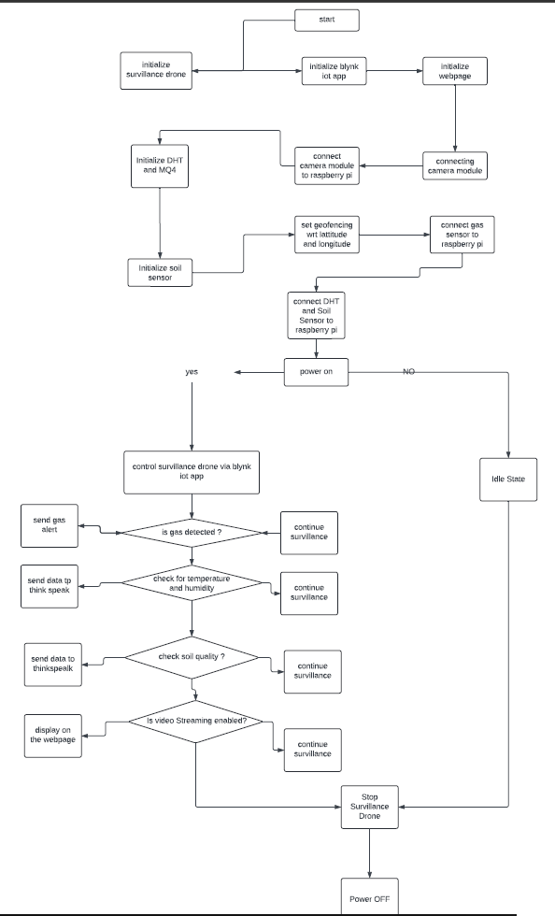

## Technologies Used

**Python -** Python is a high-level, general-purpose programming language. Its design philosophy emphasizes code readability with the use of significant indentation. Python is dynamically typed and garbage-collected. It supports multiple programming paradigms, including structured, object-oriented and functional programming.

1.Offline support: HTML5 includes features for offline storage, allowing web applications to continue working even when the user is not connected to the internet.

2.Semantic markup: HTML5 includes new semantic tags, such as header, footer, and section, which make it easier to structure and organize content on the web.

**Working of drone**

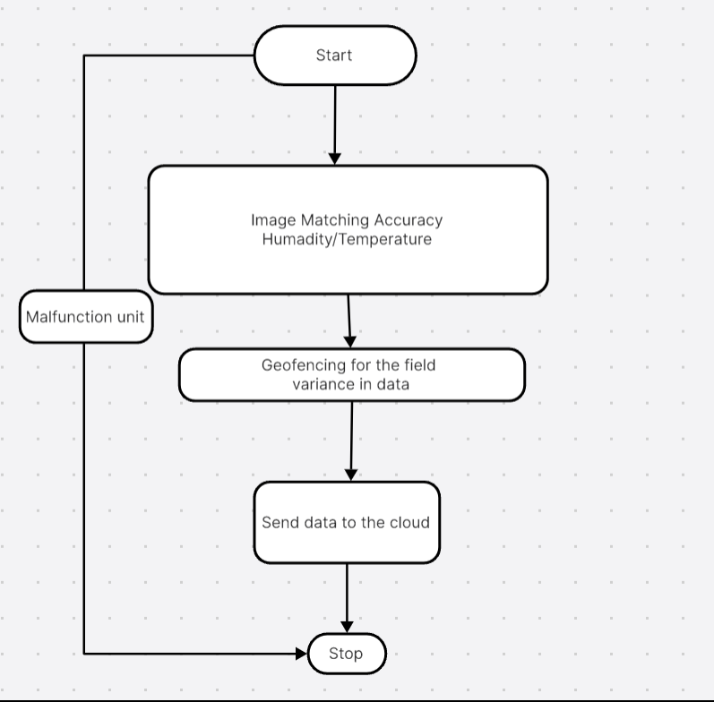

# Chapter 4: System Analysis

Requirements analysis is an important step in the development of an agricultural monitoring system using drones equipped with gas sensors. This includes understanding and documenting the needs and expectations of agricultural stakeholders. These stakeholders include farmers, agricultural experts, environmental agencies and government agencies.

Functional Requirements:

1. Environmental Data Management: The system must collect and manage environmental data, including soil quality, moisture levels, and gas concentrations.

2. Crop monitoring and management: The system must monitor the health of the crops, detect diseases and pests and optimize the use of fertilizer based on real-time environmental data.

3. Aerial Surveillance: The system should provide aerial surveillance capabilities to monitor large agricultural areas and identify areas requiring attention.

4. Early detection of crop diseases and pests: Gas sensors should detect VOCs emitted by diseased plants or pests, facilitating early intervention to prevent crop damage.

5. Optimized fertilizer use: The system should measure soil nutrient levels in real time so farmers can optimize fertilizer and improve yields.

6. Promoting sustainable agriculture: By monitoring air quality, identifying sources of pollution and assessing the environmental impact of agriculture, the system should promote sustainable agricultural practices and promote environmental protection.

Non-functional requirements:

1. Security: The system must have strong security features to protect agricultural data and prevent unauthorized access.

2. Performance: The system must work efficiently and process large amounts of data from air monitoring and environmental monitoring.

3. Usability: The system should have a friendly interface that is easy to use for farmers and agricultural experts.

4. Reliability: The system must be reliable and flexible to ensure continuous monitoring and data collection.

5. Scalability: The system should be scalable to accommodate the expansion of agricultural operations and the addition of new monitoring sites.

6. Accessibility: The system should be accessible from remote locations with internet connectivity so that farmers can monitor their fields from anywhere.

7. Compatibility: The system must be compatible with the different types of drones, sensors and data analysis tools commonly used in agriculture.

The needs analysis process is important to ensure that the agricultural monitoring system meets the needs of farmers, promotes sustainable agricultural practices and promotes agro-environmental protection.

* 1. **Hardware Requirement** Processor – Intel I3 10th Gen or Latest. Ram – 8 GB

Hard disk – 40 GB

## Software Requirement:

BLYNK IOT – Required for sending DHT and humidity sensor data to cloud. Sublime Text (Recommended) – To edit the code and for software maintenance.

Operating System - Windows 10 or Later

## Organizational Analysis

An organizational analysis of the deployment of drones equipped with gas sensors in agriculture involves identifying the organizational requirements necessary for the successful integration and implementation of the technology. This analysis examines the various stakeholders involved in agriculture, their roles and the impact of technology on their work processes.

Main stakeholders:

1. Farm Owners/Managers: These stakeholders are responsible for overseeing farming operations and ensuring that the use of drones is consistent with the farm's goals and objectives. To maximize the benefits of the technology, they must actively participate in the design and implementation process.

2. Agricultural workers: Agricultural workers play a key role in the day-to-day operations of agriculture. They must be trained to use drones safely and effectively and to integrate drone data into their work processes.

3. Agricultural Experts: Agricultural experts provide valuable insight and guidance on the use of drones in agriculture. They play an important role in advising farm owners/managers on optimal deployment strategies and interpreting drone data to make informed decisions.

4. Environmental Agencies/Governments: These stakeholders may have regulatory oversight and may issue guidelines for the use of drones in agriculture. Compliance with regulations and guidelines is essential for the legal use of drones on farms.

Organizational Requirements:

1. Training: Farm workers should receive proper training on how to use drones, interpret data and integrate them into farming practices. Training programs must be comprehensive and ongoing to keep employees informed of best practices.

2. Integration with existing systems: Drone technology should integrate seamlessly with existing farm management systems and workflows. Compatibility with other agricultural technologies is essential for effective data management and analysis.

3. Data security and privacy: Strict measures must be in place to ensure the security and privacy of farm data collected by drones. Encryption protocols and access controls should be implemented to prevent unauthorized access or data breaches.

5. Involvement of stakeholders: All stakeholders should be involved during the implementation process so that their needs and concerns are addressed. Open communication channels facilitate cooperation and acceptance by all parties.

6. Regulatory Compliance: Farm owners/managers must ensure compliance with relevant regulations and guidelines regarding the use of drones in agriculture. This includes obtaining necessary permits/licenses and following safety practices.

# Chapter 5: Expected outcome of study

1. Improved agricultural practices:

With the use of drones equipped with gas sensors, farmers can expect better agricultural practices based on real-time monitoring of environmental factors such as soil quality, moisture and harmful gases.

Early detection of VOCs caused by diseased plants or pests allows farmers to take timely action, reducing crop damage and increasing yields.

2. Optimized use of fertilizer:

The gas sensors integrated in the drones accurately measure the concentration of nutrients in the soil, which enables the optimization of fertilizers.

This precise application of fertilizers reduces over fertilization, minimizes nutrient runoff and improves yield while ensuring efficient use of resources.

3. Advanced environmental monitoring:

Drones equipped with gas sensors facilitate comprehensive monitoring of air quality, identification of pollution sources and environmental impact assessment of agriculture.

Farmers can rely on valuable knowledge about the environmental factors affecting their farms so they can implement sustainable farming practices and minimize environmental pollution.

4. Contribution to climate change mitigation:

By monitoring and implementing strategies to reduce greenhouse gas emissions, drones equipped with gas sensors contribute to climate change mitigation efforts.

Farmers can actively participate in reducing their carbon footprint by adopting precision farming techniques and ecological practices based on insights from drone-based monitoring.

5. Increased efficiency and productivity:

In general, the expected result of the study is an increase in agricultural efficiency and productivity.

Farmers can make informed decisions, optimize resources and mitigate risk, ultimately leading to better yields, lower input costs and better profitability.

6. Promotion of sustainable agriculture:

Research results promote sustainable agriculture by promoting the adoption of environmentally friendly practices and reducing the environmental impact of agriculture.

Farmers have the right to adopt practices that prioritize soil health, biodiversity conservation and ecosystem sustainability, ensuring the long-term sustainability of agricultural production systems.

In short, the expected result of research on drones equipped with gas sensors is a change in agriculture towards a more efficient, sustainable and environmentally friendly approach. By harnessing the power of technology and data knowledge, farmers can optimize their practices, mitigate environmental impacts and contribute to global efforts to mitigate climate change and achieve sustainability.

## User Interface

### Creating a user interface (UI) for drones equipped with agricultural gas sensors requires the development of a system that allows users to monitor and control environmental factors, analyze data and make informed decisions about agricultural practices. This is the interface concept:

### 1. Dashboard: The dashboard provides an overview of the most important environmental factors tracked by drones, such as soil quality, moisture and gas concentrations. It also displays warnings about detected problems or anomalies.

### 2. Navigation: The navigation menu allows users to access different parts of the user interface such as monitoring, analysis, reports and settings. It should be intuitive and easy to navigate.

### Control section:

### 1. Soil Quality: This section displays real-time data on soil pH, moisture levels, and nutrient content.

### 2. Air Quality: Users can control air gas content, humidity and temperature.

### 3. Pest detection: The system detects VOCs emitted by pests or diseased plants and provides early warning of possible infestations.

### Live Stream: Users can view real-time drone video streams while surveying an agricultural area.

### Analysis Section:

### 4. Data Visualization: This section provides visualizations of historical data trends to help users analyze patterns and identify areas for improvement.

### Statistical Analysis: Users can perform statistical analyzes of data to identify relationships and predict future trends.

### Reports Section:

### Summary Reports : Users. can generate summary reports on environmental conditions, pest activity, fertilizer use and other important metrics.

### Custom Reports: Users can create custom reports based on specific criteria and parameters.

### Settings:

### Alert Settings: Users can set alerts. thresholds for various environmental factors and choose how they want to be notified about alerts.

### Drone Control: Users can control drone functions such as flight planning, flight path adjustment and battery life management.

### User Management: Administrators can manage user accounts, permissions. , and access levels.

### Usability: the user interface must be accessible to users with disabilities and have features such as screen reader compatibility and keyboard navigation.

### The user interface for gas sensor drones used in agriculture should prioritize ease of use, data visualization, and customization options that allows users to make informed decisions and optimize agricultural practices for sustainable development and productivity.

### Chapter 6: Implementation & Testing

### The deployment and testing of an agricultural monitoring drone with a car can take place in several stages to ensure its functionality, reliability and efficiency. Here is the proposed implementation and test plan:

### 1. Prototype development:

### Develop a prototype of a convertible drone with a car prototype based on the design specifications given in the detailed description.

### Make sure the prototype includes all important components such as accelerator sensors, propulsion system, navigation and control systems, data acquisition system, safety features and user interface.

### 2. Functional testing:

### Perform functional testing to ensure that every component of the device is working as intended.

### Test ground and antenna modes separately to ensure smooth transitions between them.

### Verify the accuracy and reliability of gas sensors by simulating different environmental conditions and analyzing sensor readings.

### Test navigation and control systems to ensure accurate operation and response to user input.

### 3. Integration testing:

### Integrates all hardware components and tests their interoperability and compatibility.

### Make sure that ground and antenna modes can transition smoothly without problems or glitches.

### Test the data collection system to ensure accurate sensor data collection and processing.

### Conduct tests to ensure that safety features such as collision avoidance systems work effectively both on the ground and in the air.

### 4. Field Tests:

### Conduct field tests in real agricultural environments to evaluate device performance under real operating conditions.

### Test the device's maneuverability and stability on different types of terrain, including rough terrain, slopes and obstacles.

### Assess the accuracy and reliability of gas sensors for real-time detection and analysis of agricultural gases.

### Evaluate the usability and ease of use of the device's user interface in practical farming scenarios. 5. Performance Evaluation:

### Evaluate overall device performance based on predefined criteria such as performance, versatility, data accuracy, user satisfaction, and cost effectiveness.

### Compare the performance of the device with existing agricultural monitoring solutions to assess its advantages and limitations.

### Collect feedback from field test farmers and agricultural experts to identify areas for improvement and optimization.

### 6. Iterative development:

### use feedback from testing to refine and optimize device design and functionality.

### Please include any necessary changes or improvements to fix any issues you find or improve performance.

### Repeat the testing process to confirm the effectiveness of the changes and ensure that the device meets the user's requirements and expectations.

### 7. Development and Monitoring:

### Deploy the final version of the device for practical use in agricultural environments.

### Monitor its performance and collect user feedback to continuously improve and optimize its operation.

### Provide ongoing support and maintenance to resolve issues or challenges encountered in actual use.

# Chapter 7:Results and Discussion

1. Innovative solution:

The convertible/convertible drone represents a breakthrough in agricultural monitoring technology, providing a versatile solution that seamlessly transitions between ground and aerial operations.

Integrating the operation of both ground vehicles and drones increases the efficiency and flexibility of agricultural monitoring practices, providing farmers with comprehensive field analysis capabilities.

2. Real-time gas detection:

Equipped with advanced gas sensors, the device enables real-time detection and confirmation of certain gases that indicate various agricultural conditions, such as soil nutrient levels, pest infestation or environmental pollution.

This real-time monitoring feature provides farmers with useful information to optimize cropping strategies, reduce risk and promote sustainable farming practices.

3. Softer functions:

The sedan structure enables easy maneuvering in various terrains, while the aerial surveillance enables aerial surveillance and data collection over large agricultural areas.

By seamlessly moving between ground and air space, the device simplifies agricultural management processes, eliminates the need for separate equipment and shortens the transition time. 4. Cost-effectiveness and efficiency:

The integrated approach of the device increases efficiency and proves cost-effective for farmers by eliminating the need for several specialized tools or external research services.

Farmers can optimize farm management practices based on actionable information about soil quality, plant health and environmental conditions, increasing productivity and reducing waste of resources.

5. Sustainability and Scalability:

The device promotes sustainability in agriculture through precision farming techniques, early disease detection and environmental protection measures.

Its scalability ensures suitability for farms of all sizes, serving the needs of small businesses as well as large commercial enterprises, thereby promoting the promotion of sustainable agricultural practices.

6. Advantages over existing solutions:

Compared to existing agricultural monitoring solutions, the convertible drone with a car offers significant advantages in terms of integration, versatility, data collection capabilities and cost effectiveness.

Feedback from farmers and agricultural experts who participated in the testing emphasized the potential of the device to revolutionize the practice of agricultural monitoring and improve the efficiency of farm management.

# Chapter 8: Conclusion

The proposed method, which uses a convertible/convertible drone car equipped with advanced gas sensors, embraces a transformative approach to agricultural monitoring. It represents a fusion of cutting-edge technology and traditional agricultural practices that promises to transform the way farmers manage their crops and landscape.

1. Improved efficiency: By seamlessly switching between ground and aerial operation, the device offers unprecedented versatility for monitoring agricultural fields. This feature allows farmers to effectively cover large areas of land and provide comprehensive monitoring and analysis.

2. Real-time data analysis: Algorithms and software in the device allow real-time analysis of collected data. This feature gives farmers actionable insights to make informed decisions quickly. Whether it is detecting soil nutrient levels, detecting pest infestations or assessing environmental pollution, the device immediately provides valuable information.

3. Optimized crop management: Farmers can effectively optimize their farming strategy with the knowledge provided by the device. They can adjust watering schedules, adjust fertilizer use, and apply herbicides exactly where they're needed. This targeted approach not only maximizes performance, but also minimizes waste of resources, contributing to overall sustainability.

4. Risk reduction: Early device detection capabilities enable proactive intervention to effectively reduce risk. By identifying potential threats at an early stage, such as pest infestation or environmental stress, farmers can take quick action to prevent crop damage and minimize yield loss. This proactive approach helps secure agricultural investment and ensures the sustainability of agriculture.

5. Promoting Sustainable Practices: Perhaps most importantly, the method promotes sustainable farming practices. By providing farmers with information on soil health, pest dynamics and environmental conditions, the device enables them to implement practices that promote long-term sustainability. From optimizing fertilizer use to reducing reliance on pesticides, the method encourages ecological agricultural practices that conserve natural resources and ecosystem health.

Finally, the proposed method represents a paradigm shift in agricultural monitoring. It goes beyond traditional approaches by harnessing the power of technology to solve the complexities of modern agriculture. By enabling accurate and informed decision-making and promoting sustainable practices, the method can transform agriculture and ensure productivity, profitability and environmental protection for future generations.

# Chapter 9: References

Here are some references that were used in the development of the project:

1. <https://patents.google.com/patent/DE202022101022U1/en?oq=DE202022101022U1>
2. <https://patents.google.com/patent/AU2020101843A4/en?oq=AU2020101843A4>
3. <https://patents.google.com/patent/US10827672B2/en?oq=US10827672>
4. <https://patents.google.com/patent/EA037035B1/en?q=(survillance+drone+for+agriculture)&oq=survillance+drone+for+agriculture>
5. <https://patents.google.com/patent/KR20210076255A/en?q=(survillance+drone+for+agriculture)&oq=survillance+drone+for+agriculture&page=1>